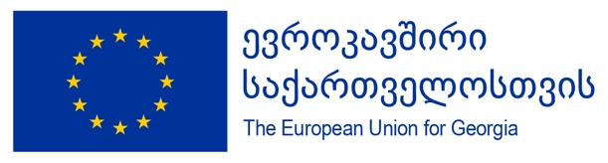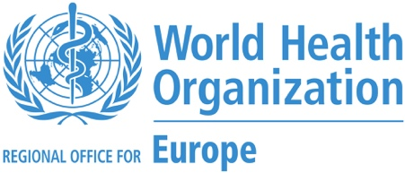

WHO support to NCDC in implementation of Vaccination Communication
March – June 2021
Deliverables | QTY | Progress to Date
Communication training for doctors | 100 | NCDC team is now conducting interpersonal and crisis communication trainings in regions of Georgia.  13-17 March – 15 trainings with 400 participants (Kutaisi, Batumi, Zugdidi, Ozurgeti, Telavi, Gori, Rustavi) conducted.  18 March – 1 April: another 24 trainings with 800 participants will be conducted.
Video Materials on vaccination | 10 | - WHO Animation: Road to COVID vaccine  Translated in Georgian, approved by EU and already posted on WHO and other social media channels  (Georgian version available here)
Video Materials on vaccination | 10 | - WHO Animation: Emergency Use Listing (EUL)  Translated in Georgian, approved by EU, ready to be posted  (Georgian version available here)
Video Materials on vaccination | 10 | - WHO Animation: Three Factors for Safe Choices During Pandemic  Translated in Georgian, approved by EU, ready to be posted  (Georgian version available here)
Video Materials on vaccination | 10 | - Doctors for Vaccination: vaccinated doctors  Working version ready; pending feedback from NCDC, MOH, and approval from EU
Video Materials on vaccination | 10 | - How vaccines work  Doctor Bidzina Kulumbekov speaking on what vaccines do, how they work; Key messages summarized as graphics on the side of the screen  In progress; working version of the video will be ready by Monday, 22 March  Feedback from NCDC, MOH, EU
Video Materials on vaccination | 10 | - Possible side-effects of Vaccination and how to manage them  Doctor Bidzina Kulumbekov speaking on what vaccines do, how they work; Key messages summarized as graphics on the side of the screen  In progress; working version of the video will be ready by Monday, 22 March  Feedback from NCDC, MOH, EU
Video Materials on vaccination | 10 | - How to be safe after vaccination  NCDC representative speaking on safety measures to be observed after vaccination.  In progress; working version of the video will be ready by Monday, 22 March  Feedback from NCDC, MOH, EU
The content of further videos is under discussion with NCDC, depending on the needs arising.
There is also a possibility to do 2 more videos under current contract.
Social Media support | 2 | Content is already being provided for NCDC FB page, including graphic posts, texts, translation of EMA statements, etc.
Social Media support | 2 | Creation of the new FB page dedicated to COVID-19 vaccination is postponed until the week of 22 March, pending results and recommendations from Zinc Network (scheduled for 23 March)
Web-page, dedicated to COVID-19 Vaccination | 1 | Web structure is already agreed with NCDC;  Web content is already in the process of development;  Deadline for the final products is 20 April, 2020
Media Partnerships | 10 | Series of Media Webinars planned for central and regional media. Each webinar is to discuss one specific topic.  First media webinar, scheduled for 19 March was cancelled last minute due to vaccination incident in Akhaltsikhe
Media Partnerships | 20 | The principles of upcoming Media Partnership are already discussed and agreed with NCDC;  Preparatory phase (identification of target regional media, negotiations of types and regularity of vaccination coverage) are already in progress.
Public Outreach |  | Concept for additional outreach to doctors with possible participation of NCDC is in the process of development.

